

**Optimizing Hospitality: Data-Driven Insights into India’s Hotel Economy**

Data analytics project

By

Basani Rakesh

**Acknowledgment**

We extend our heartfelt gratitude to everyone who contributed to the successful completion of this project, *"Optimizing Hospitality: Data-Driven Insights into India's Hotel Economy."*

We sincerely thank our mentors and instructors for their invaluable guidance and constructive feedback, which were instrumental in overcoming challenges and achieving the project’s objectives.

We are grateful to the online platform Booking.in for providing the essential data that enabled an in-depth analysis of the hospitality industry in India.

Our appreciation also goes to the tools and technologies, including Python libraries like BeautifulSoup and Pandas, as well as visualization tools such as Tableau and Power BI, which made this project possible.

Finally, we thank our peers, family, and friends for their unwavering support and encouragement throughout this journey. This project is a testament to collaborative efforts, and we are humbled by the opportunity to contribute meaningful insights to the hospitality sector.

**Chapter 1: Introduction**

* 1. **Overview of the Hospitality in India**

India's hospitality industry serves as a fundamental pillar of the nation’s economy, catering to both domestic and international tourists. Offering a wide range of accommodations, from budget-friendly hotels to luxurious resorts, the sector addresses diverse customer needs. As tourism continues to flourish, the demand for premium hospitality services grows in parallel. However, the highly competitive nature of the industry demands constant innovation and strategic optimization. To remain competitive, hotels must comprehend customer expectations and adapt to shifting market trends. In this scenario, data analytics emerges as a critical tool, empowering hoteliers to extract meaningful insights from customer data and operational metrics.

Furthermore, the hospitality sector significantly influences other industries, including transportation, food and beverage, and entertainment. As a result, optimizing this industry creates a cascading positive impact on the broader economy. This report emphasizes how data-driven strategies can transform the hospitality sector by enhancing customer satisfaction, streamlining operations, and boosting profitability.

**1.2 Problem Statement**

Although vast amounts of data are generated through online platforms and customer interactions, the hospitality industry in India faces significant challenges in effectively utilizing these resources. Key issues include:

* Limited understanding of customer preferences and sentiment.
* Ineffective pricing strategies that do not align with market demand.
* Insufficient actionable insights into regional trends and market segmentation.

Without a comprehensive approach to leveraging data, stakeholders in the hospitality sector struggle to make well-informed decisions. This project aims to bridge these gaps by applying data analytics techniques to analyze hotel reviews, pricing data, and regional trends, ultimately delivering actionable recommendations to enhance decision-making and drive growth.

**1.3 Objectives of the Project**

The primary objectives of this project are:

1. **Understanding Customer Preferences:**

2. **Price Optimization**

3. **Market Insights**

1. **Understanding Customer Preferences:**

The objective is to identify the key factors driving customer satisfaction and dissatisfaction. Through the analysis of reviews, we aim to gain valuable insights into customer expectations. These insights will enable businesses to address pain points and enhance overall service quality. The findings will support the development of targeted strategies to effectively meet customer needs.

2. **Price Optimization:**

This objective focuses on analysing pricing trends and strategies to assess their influence on customer satisfaction. By examining price elasticity and customer behaviour, businesses can refine their pricing models to strike a balance between affordability and profitability while maintaining value. Optimized pricing strategies aim to enhance customer retention and drive revenue growth.

3. **Market Insights:**

This objective focuses on analyse demand patterns and regional trends within the hospitality sector. Data-driven insights will support strategic decision-making for targeted growth. Understanding regional preferences enables businesses to personalize their offerings and align with customer expectations. These insights empower stakeholders to adapt to market dynamics, enhancing both competitiveness and efficiency. Achieving these objectives provides stakeholders with actionable tools to drive growth and operational excellence in the hospitality industry.

**Chapter 2: Data Collection and Sources**

**2.1 Data Source**

To gain insights into the dynamics of the Indian hospitality sector, data was gathered from prominent online travel platforms, specifically Booking.in. These platforms were selected for their vast databases that encompass a wide array of hotels, customer reviews, and pricing details. They offer a diverse selection of accommodations across various regions and price ranges, thereby creating a rich dataset for thorough analysis.

**2.2 Web Scraping Methodology**

The data collection process involved web scraping, a technique for extracting information from websites. The following steps were undertaken:

**1. Identifying Key Data Points:**

The project focused on collecting key information, including hotel names, locations, reviews, ratings, and pricing details. These data points were selected to offer a thorough understanding of customer experiences. By compiling this information, we were able to effectively analyse trends and patterns, establishing a solid foundation for generating valuable insights within the hospitality industry.

**2. Developing Scraping Scripts:**

To streamline the data extraction process, Python libraries such as BeautifulSoup were employed for efficient automation. BeautifulSoup was specifically utilized to parse static HTML content from web pages. For dynamic content, Selenium was incorporated into the workflow. Together, these tools facilitated accurate and seamless data collection from a variety of sources.

**3. Data Storage:**

The extracted data was organized into structured formats such as CSV files and SQLite databases to enhance accessibility. This systematic storage approach facilitated efficient data management and analysis. By using these formats, we ensured compatibility with various analytical tools.

**2.3 Challenges in Data Collection**

Several challenges were encountered during the data collection phase:

**• Dynamic Content:**

Many web pages used JavaScript to load data dynamically, requiring advanced techniques to capture the information.

**• Rate Limits:**

Websites imposed restrictions on the frequency of requests, necessitating the use of delays and proxies to avoid being blocked.

**• Inconsistent Formats:**

Variations in data formats across platforms required additional preprocessing to standardize the dataset. Despite these challenges, the data collection process yielded a rich dataset, forming the foundation for subsequent analysis.

**Chapter 3: Data Cleaning and Manipulation**

**3.1 Steps for Cleaning and Preprocessing**

The raw data collected through web scraping required extensive cleaning and preprocessing to ensure its usability. The following steps were undertaken:

**1. Standardizing Data Formats:**

Fields such as pricing, dates, and locations were standardized to maintain consistency across the dataset. This harmonization made comparisons easier and enhanced the overall usability of the data. The uniform formatting ensured compatibility with analytical tools and minimized errors during the analysis process.

**2. Removing Duplicates:**

Duplicate records in the dataset were identified and eliminated to ensure accuracy in the analysis. This step was critical to avoid redundant information skewing the results. By removing duplicates, the dataset became cleaner and more reliable. This enhanced the overall quality of insights derived from the data.

**3. Handling Missing Values:**

Missing data was managed using appropriate imputation techniques or exclusion based on its significance. Imputation helped fill gaps in the data without compromising analysis accuracy. Exclusion was used when the missing data was minimal or irrelevant. This ensured the dataset remained comprehensive and meaningful.

**4. Creating Derived Metrics:**

Additional metrics, such as average price per region and sentiment scores, were calculated to enhance analytical depth. Derived metrics provided new perspectives and improved decision making. These metrics allowed for more granular and actionable insights.

**5. Sentiment Labelling:**

Textual reviews were analysed to determine their sentiment as positive, negative, or neutral. Sentiment analysis provided valuable insights into customer opinions. Categorizing reviews helped identify trends in satisfaction or dissatisfaction. This added a qualitative dimension to the analysis.

**3.2 Tools Used**

**• Pandas:** For data manipulation and preprocessing.

• **NumPy:** For handling numerical data and calculations.

**• OpenRefine**: To assist with standardizing and cleaning data.

**3.3 Importance of Data Cleaning**

Data cleaning is a vital component of any analytics project, as the accuracy of the analysis relies heavily on the quality of the data used. By systematically addressing inconsistencies and filling in missing values, this project has ensured that the dataset is dependable and comprehensive, laying the groundwork for insightful findings. Clean data is crucial for informed decision-making, as it accurately captures the underlying characteristics of the phenomena being studied. By rectifying inconsistencies, managing gaps in the data, and standardizing formats, data cleaning creates a strong basis for effective analysis. Additionally, having clean data enhances algorithm performance and reduces computational strain, making it easier to extract meaningful insights. In industries like hospitality, where decisions often hinge on subtle trends and customer feedback, the significance of clean data is paramount. It empowers stakeholders to focus on actionable insights without being hindered by irrelevant noise or inaccuracies in the dataset.

**Chapter 4: Data Analysis and Insights**

**4.1 Analysis of Customer Reviews**

Customer reviews provided valuable insights into customer preferences and satisfaction levels. Text analysis techniques were used to extract key themes and sentiments:

**1. Sentiment Analysis:**

Customer satisfaction was predominantly driven by positive reviews that highlighted cleanliness, high-quality service, and a convenient location. These reviews often focused on the favourable features that contributed to a delightful experience. In contrast, negative reviews tended to highlight problems such as insufficient maintenance and elevated pricing. This analysis shed light on critical areas that require attention and improvement.

**2. Keyword Analysis:**

To uncover commonly referenced terms in customer reviews, word frequency analysis was utilized, highlighting phrases like "clean rooms," "friendly staff," and "poor Wi-Fi." This technique revealed recurring themes and critical factors that customers associate with their experiences. By analysing these key terms, businesses can identify and prioritize the aspects that most significantly affect customer perceptions.

**4.2 Pricing Trends and Strategies**

The pricing data revealed several interesting patterns:

**1. Correlation Analysis:**

A strong correlation was observed between pricing and customer satisfaction in budget hotels, indicating that pricing significantly affected customer perceptions. Conversely, luxury hotels demonstrated a weaker correlation, implying that aspects such as service quality and amenities played a more critical role in determining customer satisfaction. This analysis offered valuable insights into how pricing influences different segments of the market.

**2. Competitive Pricing:**

Areas with a high density of competing hotels showed narrower price ranges, highlighting the significance of competitive pricing strategies. In these markets, hotels need to adjust their prices to attract customers effectively. The analysis revealed that maintaining competitive pricing is essential for preserving market share.

**3. Seasonal Trends:**

Price variations were observed in relation to seasonality, with rates surging during high-demand times like holidays and vacation periods. This pattern demonstrated the effect of travel demand on pricing strategies. By implementing seasonal pricing adjustments, hotels could enhance revenue during peak seasons while offering lower rates during off-peak times.

**4.3 Market Segmentation and Demand Patterns**

Market segmentation analysis revealed:

**1. Regional Trends:**

Major cities like Mumbai and Delhi experienced steady demand throughout the year, thanks to a constant stream of business and leisure travelers. In contrast, tourist destinations such as Goa faced pronounced seasonal demand increases, especially during peak vacation periods. This disparity underscored the importance of implementing distinct strategies to accommodate the differing demand patterns across various regions.

**2. Customer Segments:**

Three key customer segments were identified: budget travellers, mid-range travellers, and luxury seekers. Each group has its own distinct preferences and expectations: budget travellers look for affordability, mid-range travellers appreciate comfort and quality, and luxury seekers desire premium experiences and exclusive amenities. Recognizing these differences enables more effective marketing and personalized service offerings. These insights provide a deeper understanding of the dynamics within the Indian hospitality industry, allowing for the creation of targeted strategies for improvement.

**Chapter 5: Visualization and Interpretation**

**5.1 Key Visualizations for Tier 1 Cities**

To illustrate the findings, several visualizations were created:

**1) Top 5 Hotels based on distance:**

A pie chart illustrates the average distance from the central city by hotels. In it shows the hotel name which is near to central of the city in the kms.

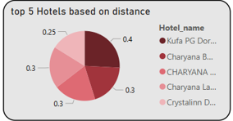

**2) Top 5 hotels and ratings by total reviews:**

A column chart illustrates the top 5 hotels and ratings based on total reviews. In it hotels are placed in x-axis and average rating are placed in y-axis and filter by total reviews.

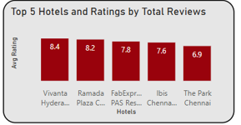

**3) Top 10 Rating and room type by Total Reviews:**

A line chart illustrates top 10 Ratings and Room Type by total reviews. In

It room type is placed in x axis and average rating is placed in y axis and filter by total reviews.

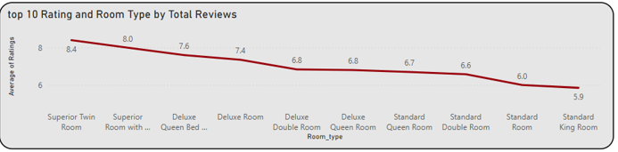

**4) top 5 room type by average price:**

A bar chart illustrates top 5 room type by average price. In it room type is placed in y axis and average price is placed in x axis and it filter by average price. In it room type show in tooltip.

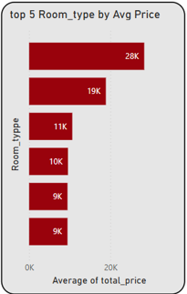

**5) average price by average rating**

a scatter chart illustrates average price by average rating. In it rating is placed in y axis and price is placed in x axis. For example, the data having average rating of 9.0 and it costs around 15k.

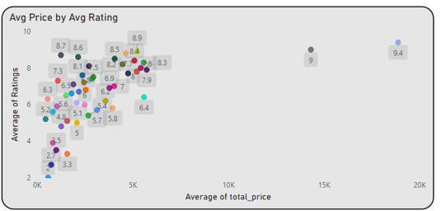

**6) average price by distance:**

An area chart is presented by average price by distance for central city. In it the distance is placed in x axis and price is placed in y axis.

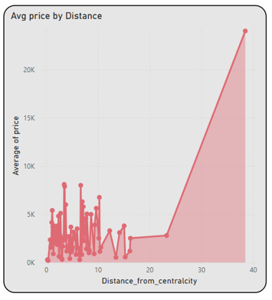

The table is showing the location wise maximum price, minimum price, total reviews, maximum rating, minimum rating.

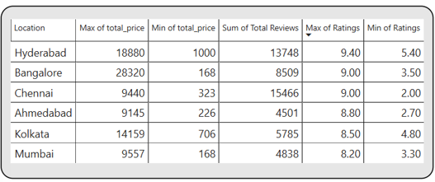

The card are represent, In it average price, average tax, tax percentage, average distance from central city.

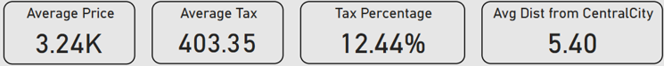

**5.2 Tools Used**

• **Power BI**: For advanced visualizations.

• **Python:** Libraries such as Matplotlib and Seaborn for static visualizations.

**Chapter 6: Challenges Faced**

**6.1 Technical Challenges**

The technical challenges encountered included:

**1. Large Data Volumes:** Handling large datasets necessitated the use of optimized algorithms to ensure efficient data processing. These algorithms helped manage the complexity and scale of the data without compromising performance. Additionally, efficient storage solutions were implemented to store vast amounts of data in a way that facilitated quick retrieval and analysis. This approach ensured smooth handling of large volumes of information.

**2. Unstructured Data:** Extracting meaningful insights from unstructured text data, such as customer reviews, required advanced preprocessing techniques. These techniques, such as text cleaning, tokenization, and sentiment analysis, helped convert raw data into a structured format for analysis. The goal was to transform the unstructured data into valuable insights that could inform business decisions and improve customer experience.

**6.2 Dataset Limitations**

**1. Incomplete Data:** Certain regions had sparse data, which limited the depth and comprehensiveness of the analysis. The lack of sufficient data from these areas made it challenging to draw meaningful conclusions about customer preferences and trends. Efforts were made to mitigate this issue by focusing on available data while acknowledging the limitations in the analysis.

**2. Data Bias:** Reviews were disproportionately concentrated on popular hotels, which potentially skewed the results. This bias may have led to overemphasis on well-reviewed hotels while underrepresenting smaller or less popular establishments. Recognizing this bias was important for ensuring that the findings provided a balanced view of the hospitality landscape.

**Chapter 7: Conclusion and Recommendations**

**7.1 Summary of Findings**

This project has highlighted the transformative potential of data analytics in the hospitality industry. Key findings include:

• Customer satisfaction is driven by factors such as cleanliness, staff behavior, and amenities, with pricing playing a significant role, particularly for budget hotels.

• Seasonal demand and competitive pricing are critical for optimizing revenue and occupancy rates.

• Regional trends and customer segmentation offer valuable insights for tailoring services and marketing strategies.

**7.2 Recommendations for Stakeholders**

1. Focus on Service Quality: Hotels should prioritize improving cleanliness, staff training, and maintenance to enhance customer satisfaction.

2. Implement Dynamic Pricing: By adopting dynamic pricing strategies, hotels can better align their rates with demand fluctuations and market conditions.

3. Leverage Customer Feedback: Regularly analyze customer reviews to identify areas for improvement and innovate service offerings.

4. Adopt Regional Strategies: Customize marketing and operational strategies based on regional demand and preferences to attract more customers.

5. Invest in Data Analytics: Develop in-house analytics capabilities or partner with analytics firms to continuously derive actionable insights.

**7.3 Final Conclusion**

This project underscores the importance of embracing data-driven decision-making in the hospitality sector. By leveraging the insights provided, stakeholders can make informed decisions to refine their operations, enhance customer experiences, and contribute to the sustained growth of the Indian hotel economy. The integration of advanced analytics and technology will not only address current challenges but also prepare the industry to adapt to future trends and disruptions, ensuring long-term success.

**Chapter 8: DASHBOARD VISUALIZATION**

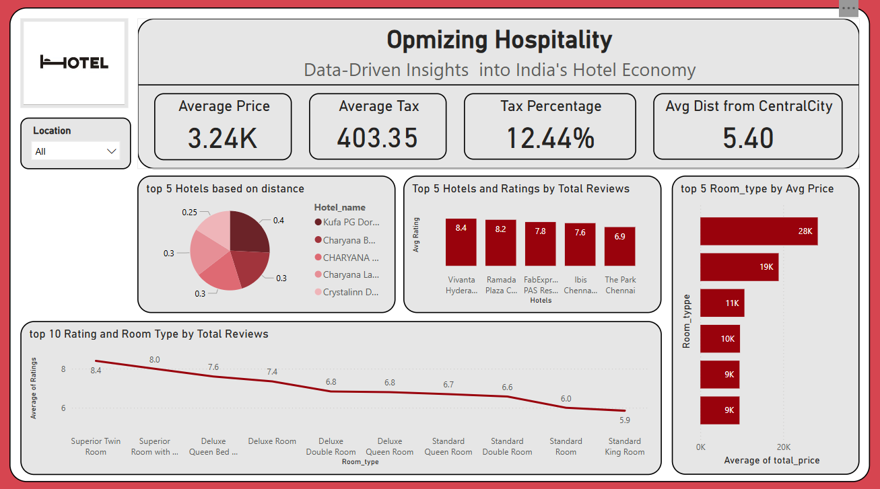

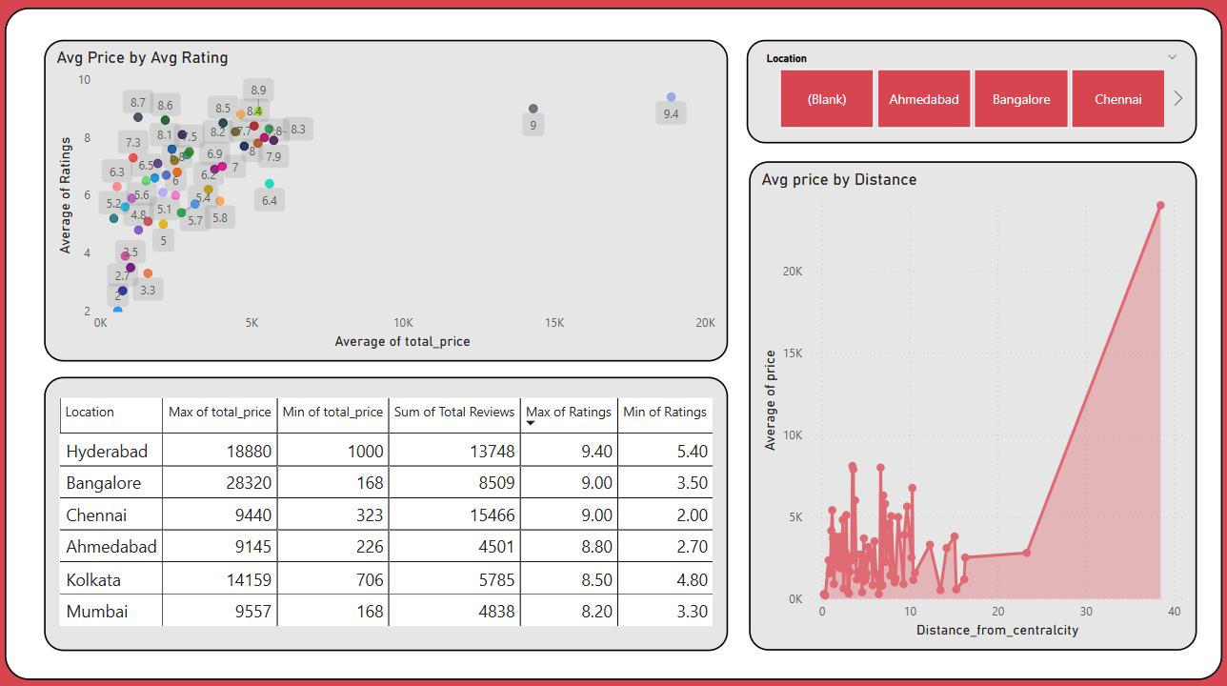

**Chapter 9: Tools and Technologies Used**

**8.1 Web Scraping**

**• Tools:** BeautifulSoup, Selenium.

**• Purpose:** Extracting structured data from online platforms.

**8.2 Data Cleaning and Manipulation**

• **Tools:** Pandas, NumPy, OpenRefine.

• **Purpose:** Preparing data for analysis**.**

**8.3 Analysis and Visualization**

**• Tools:** Tableau, Power BI.

**• Purpose:** Generating insights and creating visualizations.